Name | YELLA GOUTHAM
Class | 8 T

Purpose:
"Skill Assessment Program - Building Strengths Beyond Academics "
This report shows your child's interests and abilities in different school activities. With your (parents) support and our guidance, these strengths can grow into useful life skills. It helps parents notice early signs of talent and areas where extra care or practice can make a big difference.

Key Insights:
The graph below shows how your child is doing in different areas. It tells us what they like more and where we can help them do even better. Blue represents your child, and orange represents the class average.
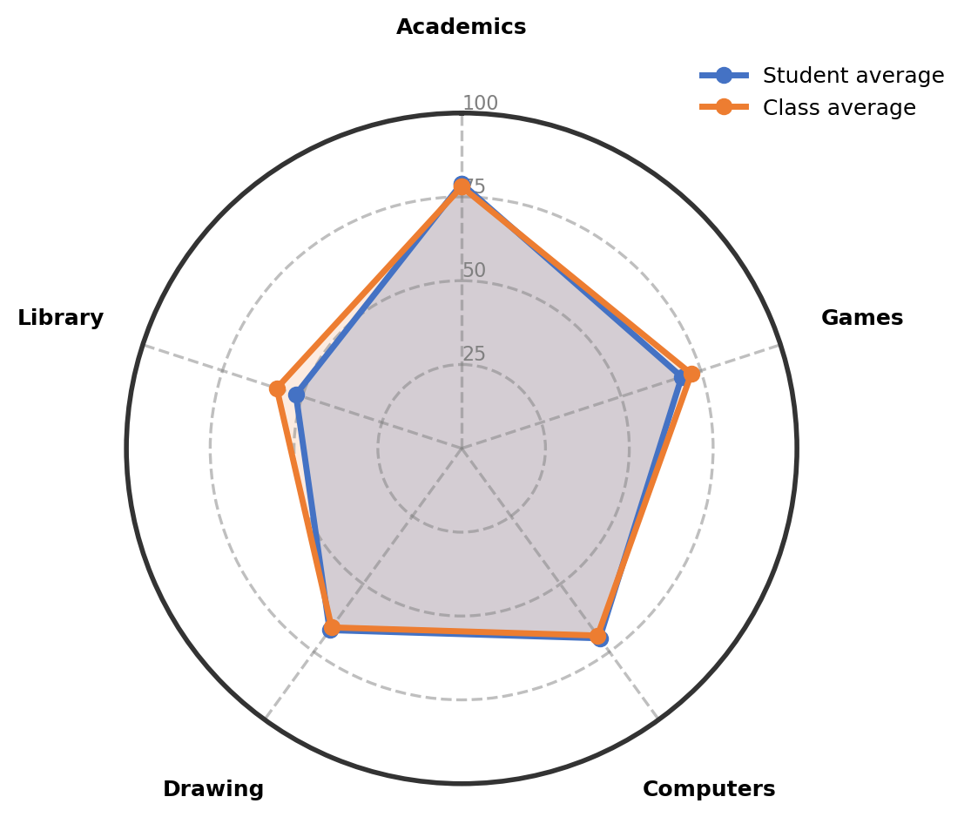

Observations:
The table gives an overview of child's involvement and performance across co-curricular areas.
Interest Area | Engagement (%) | Interest Level | Key Observations
Academics | 79% | Showing Strong Interest | Shows strong interest in academics, especially in agriculture. The child learns well and engages with the subject.
Computers | 70% | Well-Developed Interest | Participates in computer class and answers well, though needs encouragement to stay motivated. Shows interest in games like GTA.
Games | 69% | Well-Developed Interest | Enjoys playing kho kho, badminton, and shuttle. Performs well and shows good skills in these games.
Drawing | 67% | Well-Developed Interest | Actively participates in drawing class and is learning shading and blending techniques. Shows average performance and needs practice for better tonal transitions.
Library | 52% | Developing Engagement | Interested in reading moral stories and comic/crime thrillers. Has a good vocabulary and participates in library activities.

Recommendations & Growth Opportunities:
Here are some ways to turn your child's interests into long-term strengths:
Strong Interest Area | Potential Careers | Simple Activities to Support
Academics  (79%) | Strong academic performance, especially in agriculture, can lead to exciting career paths. Exploring Biotechnologist, Environmental Scientist, Indian Forest Service Officer, or Agricultural Scientist is very possible. These fields combine a love for science with practical work in farming and nature.  Combined Career Paths: Biotechnologist, Environmental Scientist, Indian Forest Service Officer, Agricultural Scientist | 1. Enroll in a science foundation course that covers biology and agriculture topics to build a strong base  2. Encourage participation in school science fairs or agriculture-related projects to apply learning  3. Provide books or documentaries about farming, biotechnology, and environmental science to deepen interest.
Computers
(70%)

How Parents Can Help:
1. 1. Weekend Exploration (Academics - Biology/Agriculture): Dedicate a weekend afternoon to visit a local farm or agricultural exhibition to spark curiosity in agriculture and biology.
2. 2. Short Daily Practice (Computers): Encourage 15 minutes of typing practice or basic coding on free platforms like Code.org to build logical thinking.
3. 3. Encourage and Talk: Dedicate 10–15 minutes weekly to ask about favorite subjects, what new things were learned, and celebrate small academic wins.

Conclusion:
This child shows a wonderful mix of academic interest, especially in agriculture, along with good sporting and computer skills. With steady encouragement and practical exposure, these strengths can open many rewarding career paths. Keep celebrating the effort and curiosity—every step builds confidence for the future. Your support is the foundation for this growth.

Notes:
Parents remarks:
Teachers' remarks:

